Project Design Phase
Problem – Solution Fit Template
Date | 14 July 2026
Team ID
Project Name | HouseRent India — MERN Property Rental & Sale Platform
Maximum Marks | 2 Marks

Problem – Solution Fit Template:
Problem-Solution Fit confirms that the problem identified for HouseRent India's users is real, and that the proposed solution genuinely resolves it for their existing behaviours and channels.

Purpose:
- Solve the listing-trust and communication gap in a way that fits how Indian renters, buyers, and owners already search and negotiate.
- Increase adoption by working through the same channels (search, direct messaging) users already expect, minus the broker middleman.
- Sharpen the value proposition: verified owner-posted listings + direct in-app negotiation.
- Build trust by solving the most frequent, costly annoyance — duplicate/fake listings and unstructured phone-based enquiries.

Canvas:
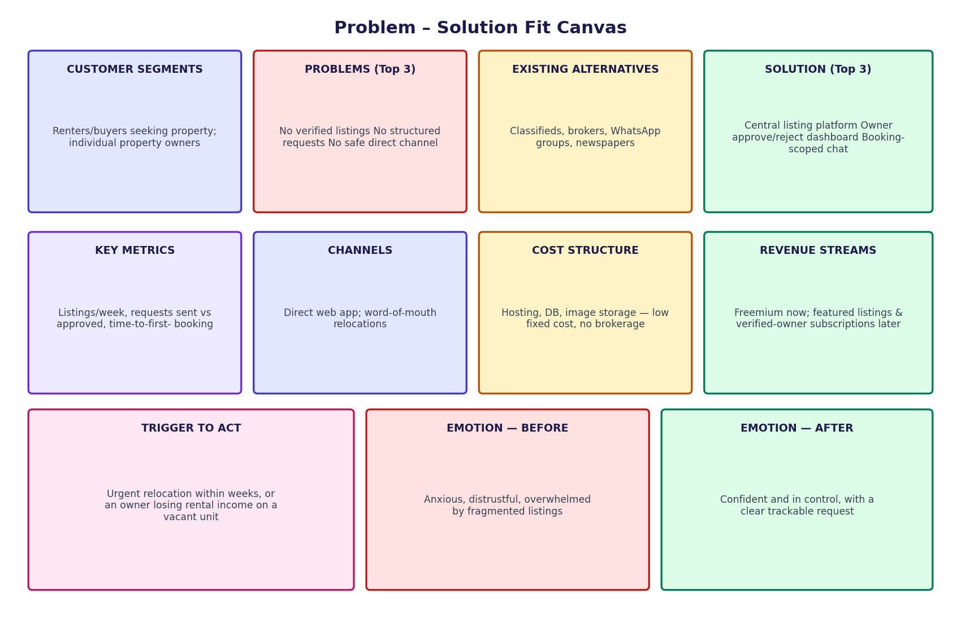
Figure 1: Problem – Solution Fit canvas for HouseRent India

Segment | Details
Customer Segment(s) | Renters and buyers searching for residential/commercial property in Indian cities; individual property owners with rent or sale listings.
Problem — Top 3 | 1) No trustworthy, verified source of listings.  2) No structured way for owners to receive and track requests.  3) No safe, direct communication channel once interest is expressed.
Existing Alternatives | Classifieds sites, local brokers/agents, WhatsApp property groups, newspaper listings — all fragmented, often outdated, and charge brokerage.
Solution — Top 3 | 1) Central, searchable, filterable listing platform.  2) Owner dashboard to approve/reject booking requests.  3) In-app chat scoped to each booking, once a request is sent.
Key Metrics | Listings published per week; booking requests sent vs approved; time from listing to first booking request; renter/owner retention after first successful booking.
Channels | Direct web app (React SPA); word-of-mouth among relocating professionals; future integration potential with local classifieds for discovery.
Cost Structure | Hosting (Node/Express server + MongoDB Atlas), image storage, and domain — low fixed cost typical of a lean MERN deployment; no brokerage payouts.
Revenue Streams | Freemium listings now; future featured-listing fees and verified-owner subscriptions.
Trigger to Act | An urgent need to relocate/move within weeks, or an owner with a vacant unit losing rental income each month it stays unlisted.
Emotional Response (Before) | Anxious, distrustful, overwhelmed by fragmented, low-quality listings and unstructured enquiries.
Emotional Response (After) | Confident and in control — a clear, trackable request status and a direct channel to the other party.

